**TO CREATE PROJECT USING CUBE SUITE**

* First appearance of cube suite page CLICK OK

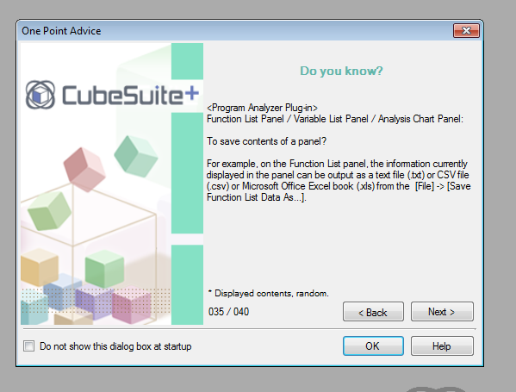

* CLICK GO option of “Create New Project”

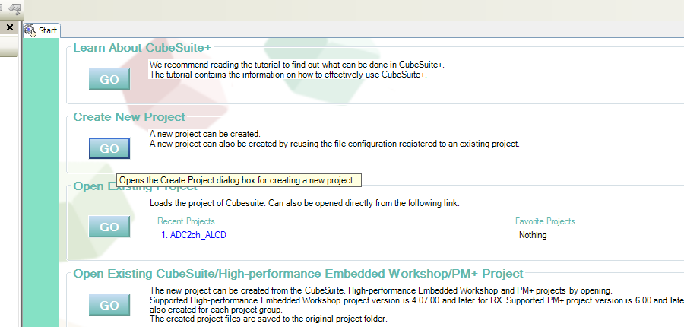

* Select Controller, give a project name and folder will be created with the same name and CLICK CREATE

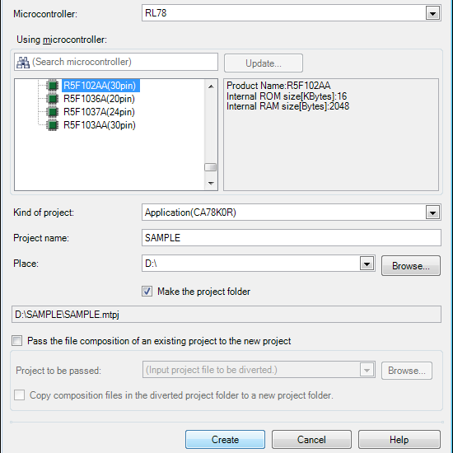

* Select “code generator” and CLICK “Fix settings”

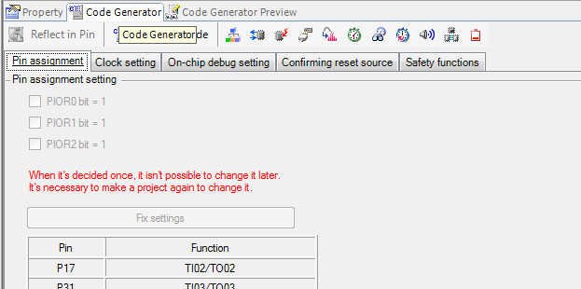

* Select “Watchdog Timer” and make it as “Unused”

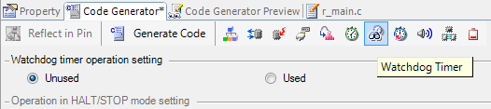

* Select required peripherals

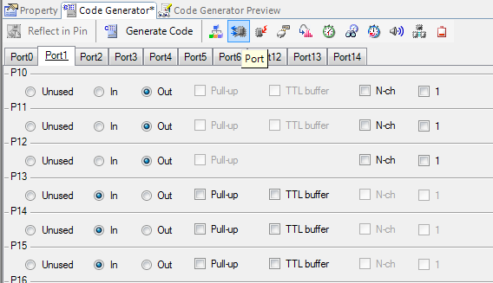

* After Selecting required peripherals CLICK ON “Generate Code”

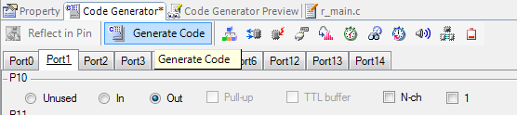

* Files generated with Main file

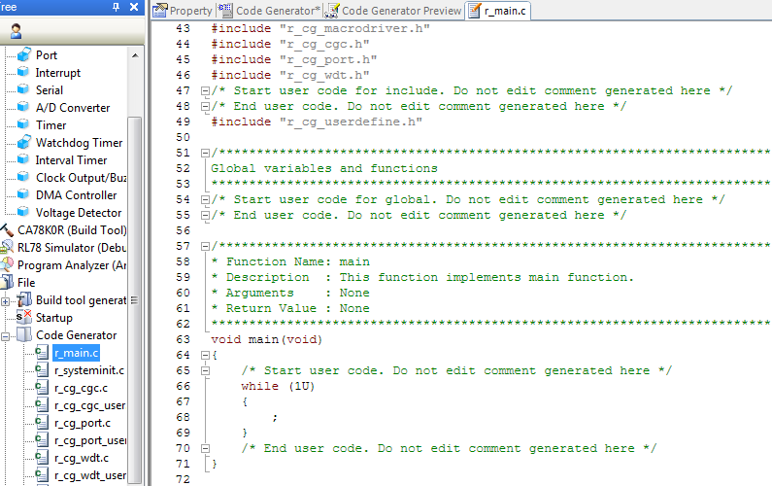

* Build Project

